Professor Amanda Howe OBE FRCGP
President
January 2020
Dear Colleague,
The RCGP wants to say thank you to you and your practice for teaching undergraduate medical students.
This letter is being sent via your local medical school GP training leads, who have kindly agreed to let us mark the New Year by acknowledging and saying thanks for your input into undergraduate teaching. We want to get a message out to the teachers on the front line – the ‘unsung’ heroes – who students often cite when they tell us who first inspired them to think about becoming a GP. So please let your colleagues and all who contribute know – we all appreciate their work in making better doctors for the future and helping to make more of them interested in general practice.
We know that positive experiences of general practice as a clinical and learning environment has a major impact on medical student career choice. Years of effort to get more input and better placements at undergraduate level is leading to better outcomes for GP training recruitment, and stronger voice for GP in the medical schools. It can be hard work to add something into the day job, especially in the present climate. But you, your team, and your patients are making a big difference to the future – and hopefully finding your involvement interesting too.
It’s not enough just to say thank you – the RCGP has been working with the Society for Academic Primary Care (SAPC) and local GP teaching leads on issues such as funding for undergraduate teaching; supporting student-led GP societies; delivering a range of Discover GP events; and most recently development of curriculum guidance – to name but a few initiatives. Please feed back to us what might also help – and stories of what works also very welcome! So thanks again, best wishes for the New Year, and
Your Sincerely – on behalf of the whole RCGP,
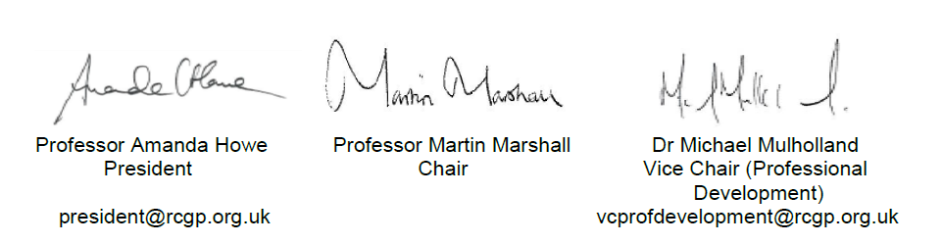
P.S. You are welcome to add this message to a screen, practice website or newsletter. Also, if you have any ideas on how to develop this area of work, please contact your local RCGP faculty and the local GP teaching lead who sent this email on our behalf – we thank them too!
To find out more about what the College is doing to support tomorrow’s GPs, please visit rcgp.org.uk/discovergp.

Royal College of General Practitioners 30 Euston Square London NW1 2FB
Tel 020 3188 7400 Fax 020 3188 7401 Email inof@rcgp.org.uk Web www.rcgp.org.uk
Patron: His Royal Highness the Duke of Edinburgh Registered Charity Number 223106

